

Dead River Campers, Inc.
P.O. Box 323
Ishpeming, Michigan 49849

www.deadrivercampersinc.com

Peter Dishnow
President

Dead River Campers News

Year 2008 – Edition 3

Silver Lake Restoration- Silver Lake project is on schedule to be completed by November 15th, 2008. Major concrete sections of the new spillway were completed on October 31st. Most of the dikes, new Dam 2 and extensions have been brought up to design elevations. The remaining majority of the work will be finishing earth work around the project.

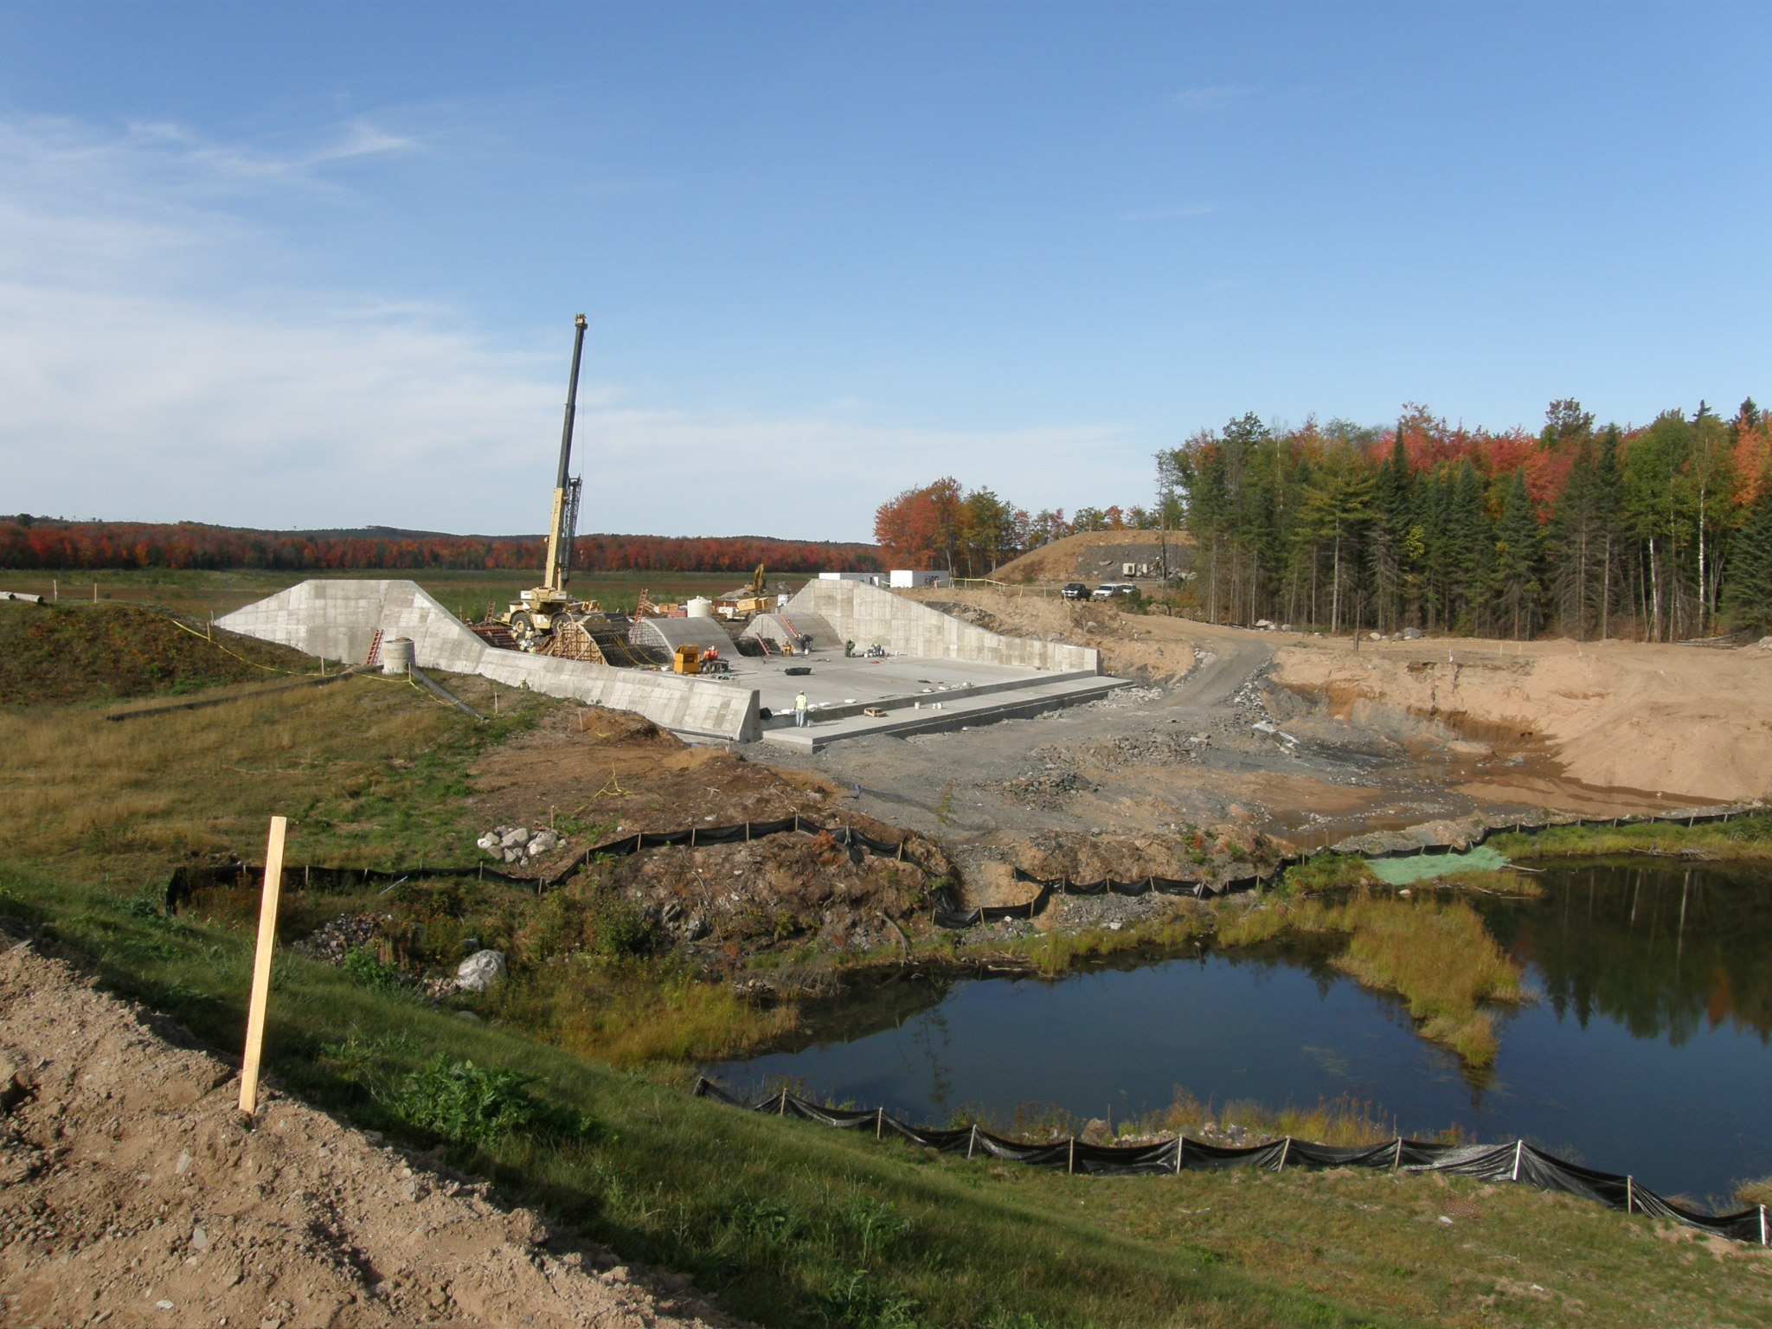

Board Meetings –Your Board held regular meetings this quarter on July 14th, August 5th, August 26th, September 8th and September 23rd.

Issues of Interest- There has been quite a bit of activity on boat launches this quarter. Most of the emails and discussions have been in regards to the West End Launch. UPPCO has been considering a site for the West End Launch at the old Spiroff campsite on the upper end of the Barnhart. UPPCO is now unable to get an easement from the Michigan Nature Conservatory to access the proposed site. This was pointed out by DRCI when the site was first suggested. Unfortunately, UPPCO has put quite a bit of work and planning into this site. DRCI was also insisting that any launch at this site be placed as far as possible from existing shareholder camps. UPPCO is required by their FERC license to put two boat launches, one West and one East, on the Hoist Basin. UPPCO is back to searching for a new site for the West End Launch.

Repairs to the Holyoke Bridge footings on North Basin Drive were completed this fall.

DRCI planted 45,000 Red Pine seedlings north of the Red Road in the area where diseased trees were removed last year. We will also plant up to 2000 2’ to 3’ White Pines along the road as a buffer later this fall or early next spring. Signs will be placed in this area warning people to keep off of the new trees with ORV’s and snowmobiles.

UPPCO is reminding all campers to keep personal property, such as pontoon boats and trailers, off of the power line right of ways. They will need access during the winter for their machines to travel these lines to remove trees and make repairs. This has become a big issue with UPPCO in providing electrical service around the basin to more and more year round residents.

The DRCI Board will be offering a standing reward for information leading to the arrest and conviction of any person involved in the break-in of a DRCI shareholder’ property. Please be aware of strange vehicles and persons in the area of your camp and your neighbors.

Finance Committee- During the last quarter we have been working with Wells Fargo as our selected investment bank to handle our investment portfolio. As our bank CD’s mature from other banks these funds are being invested in accordance with our investment policy and with particular concern of the recent volatility and upheaval in the market.
The committee members are:

Peter Dishnow, President, DRCI
Darryll Sundberg, Treasurer, DRCI
Joseph Ervin, Senior Vice President, Global IT Initiatives & Sourcing
K. Denise Albrecht, Regional Trust Manager, US Bank Private Client Group
William Stream, President, Peninsula Bank

UPPCO Veneer Land Sale –The HBEELA sale has finally been completed. All of the HBEELA campers ended up participating and buying their frontage in the sale. Please join the Board in welcoming all of the former HBEELA campers as DRCI shareholders.

Fish & Wildlife Committee- First, we would like to thank all of our members and the board of directors for your continued support. It makes our challenge a lot easier. We got a lot accomplished this year. It was good to be busy again since everything has been on hold since the flood. We fully supported the D.N.R. plan to restock the basin with trout while continuing the walleye and perch program. To date, brook trout have been planted below Silver lake and lake trout in the basin. (950 in July - average 18 inches, approx. 600 in Sept.- average 22-24 inches) The DNR notified us that the Federal Hatchery planted the Hoist Basin with Lake Trout in September without notifying any of the participating groups including DRCI. They planted 200 2001 Seneca Lake Wild Strain on September 9th, 300 2003 Seneca Wild Strain on September 10th and 82 2001 Seneca Wild Strain on September 12th. A plant will also be made in late October. These are all the good eating "reds". We are hopefully looking at a walleye plant in the spring. In support of these plants, DRCI planted 250,000 fathead minnows in September. These minnows should spawn at least twice every year. It is our goal to get a minnow population re-established to promote bigger walleye and perch while continuing to support the trout effort. We plan to be aggressive and work closely with the D.N.R. to improve the basin fishery.
Other projects in discussion include continuing to work on the duck, owl and other wildlife programs and also looking forward to working with the campers group on getting back to an annual fishing contest and/or a fishing derby.
Your committee members are Gordy Chinn, Brenden Biolo, Buffy Ervin, Tom Polkinghorne, Dave Laitinen and board member Lee Woods. We appreciate your input and let us know if you’re seeing or catching any Lakers etc. Thanks again, we'll update with the next newsletter and include a great recipe for pickled northern

REMINDERS

Water Surface Elevation- If you are interested in the water surface elevation, log onto http://www.wisconsinpublicservice.com/news/hydro/hydrodata.asp or get to this same website via the DRCI website link for current information. We thank UPPCO for making this information available to us.

Plowing Snow Across Public Roads- Marquette County Road Commission reminds us that Public Act 300 of the Public Acts of 1949 as amended under section 677a states that it is against the law to deposit, or cause to be deposited, snow, ice or slush on any roadway or highway or shoulder of roadway/highway. When people violate this law it can cause traffic safety problems. This also causes concern for snowplow drivers and has caused damage to snow removal equipment. It is the intent of Marquette County Road Commission to seek enforcement of this law.

Tree Removal Issues –If you have trees to remove please fill out a cutting permit and send it in to DRCI or contact Bruce Bussone at 485-5901. There have been 57 cutting permits approved so far this year. We had a total of 78 permits last year. The process is working very well, with marking the trees or meeting with Bruce in person. In an effort to maintain some control on time limits, the Board has put a limit of 1 year from date of issue for tree cutting permits. Each shareholder is responsible for any trees cut by contractors you have hired. Please contact Bruce if you have any questions. You are reminded that tree cutting on common /CFR lands is prohibited. If anyone has a problem with this issue feel free to contact your board.

Road Improvements- Shareholders are reminded to get permits for road improvements. This would include any changes to current roads as well as tree removals to widen access. Each shareholder is responsible for roadwork done by any contractor you have hired.

Bridges- DRCI committed to maintain two bridges in our original documents, they are located on North Basin Drive and Three Mile Road. Please report any bridge damage you observe to the Board immediately.

Stock Certificates – You are reminded to update your stock certificate ownership and addresses when something changes that would change those certificates. This would include a death, divorce, move, etc. Your ballot must be signed by all owners for it to be valid. There is no charge to change the certificate and it can be done easily by sending the certificate to DRCI with supporting documents for the change. Please let new shareholders know that they should submit a copy of their deed and obtain a stock certificate upon purchase of their camp. Additionally, the corporate bylaws, declarations, rules and regulations can be found at our webpage at www.deadrivercampersinc.com

Zoning Violations-Shareholders should report perceived zoning violations to their respective townships. These violations would include multiple camps on single lots and excessive blight or junk. The townships can be contacted at, Ishpeming Township-485-5411, Negaunee Township-475-7869 and Champion Township-339-2920.

